GeoVision 450 (MS-5654)
Trouble Shooting Guide

Version: 1.1
Model | GeoVision 450  (MS-5654)
Date | Version | Notes
04/10/2008 | 1.1 | Release

1. Main function
1.1 Block diagram
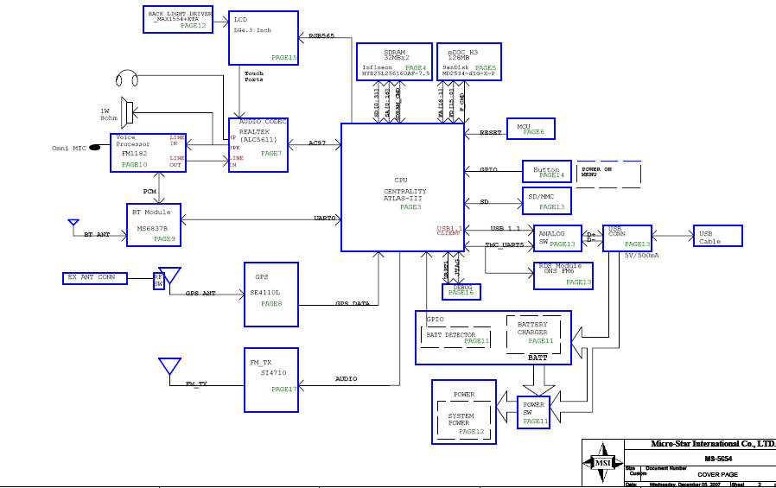

1.2 CPU (CENTRALITY/ATLASIII) – U1

. CPU mainly divides for 6 units such as (ARM926EJ) processor, Memory Subsystem, DRAM interface, Display Controller, Connectivity, System Peripheral.
(1) ARM926EJ: The main function is that data process, operation of order and communicating to control other internal and external units.
(2) Memory Subsystem: Mainly responsible for transforming or receiving data from ROM, NAND Flash, NOR.
(3) DRAM interface: Mainly responsible for transforming or receiving data of DRAM.
(4) Display Controller: Responsible for transforming video signal to LCD panel
(5) Connectivity: The main function is for expanding CPU peripheral interface function , for instance: AC97 Bus, I2C Bus, USB Host, USB Device, UART, Memory Card , etc..
(6) System Peripheral: The main function is control within CPU and treatment unit, for instance: Clock Controller, interrupt controller, RTC, DMA, GPIO, etc.

  - mDOC H3 Flash (SANDISK/SDED5-002G-NCY) – U33
Mainly used for storing the software procedure (Image) , BIN file. CPU setting, the all Chip's driver, and test procedure.

  - Mobile SDRAM (HYB25L256160AF-7.5) – U2, U3
While system processing data, CPU will store data here temporarily .example: Play MP3,CPU will load data from SDRAM

  - Audio Codec (REALTEK/ALC5611D-GR) – U7
Audio codec will transfer digital signals to analog audio source, via Internal Audio AMP, export
it to Speaker or Headphone jack.

  - Power ON/OFF Switch – SW4
Used for making Device Suspend / Resume function.

  - Battery OFF Switch – SW3
The switch that is used for locking battery device, when SW3 off, system can't be power on/off by inside or outside power.

  - Indicator LED – LED1
Power on, and charging--- orange light.
Power off, and charging--- orange light.
Power on, finished charging---green light.
Power off, finished charging---green light
No charging (not insert the outside power outside) ,power on---no light.

1.9 LCD Backlight Power IC – U19
Used for transforming the voltage that back light LCD module needs.

3.Repairing Diagram
Step.1 power check
Check all voltage checking point
Whether short ,cold solder , lack of component wrong position
PCBA that already finished, do not connect the power,
Repair the issue:
short , cold solder
,lack of components.

Yes
No

Short or not
Look for relative power area
short, open position

Step.2
Yes
No
Step.2 function check
1. check X1 ,work or not
2. check all power components
U21,U23,U17,U30
3. check SDRAM Clock(R38), Power PWR_SDRAM(L2)
4. check mDOC H3 Power
VNAND(R39)

POWEN ON , Open system
1. check U19 voltage
2. J7 connect check
3. Check RA7~RA12 AND R112 LCD Bus components
Check function of LCD panel
No

Yes

Display back light correct or not

No
1. Check J7

Yes

Confirm Button function correct or not

No
1. Check SW1/SW2/ SW3

Yes

SD-MMC can write or not

1. Check J12 PIN5 POWER
2. Check SD-MMC peripheral components
Plug in Earphone, Can or not hear
Yes
No

Check J20 Pin4 and peripheral Component
No

Yes

Check TSPX/TSMX/ TSPY/TSMY reference circuit

Touch Panel function correct or not

No

Yes

AC97 Codec Can or not hear sound use speaker
No

Check J2 / U7 reference circuit

Yes

GPS can or not receive signal

No
1. Check G_J1
2. Check U28
3.POWER U25 U26
3.Y1是否有起振

Yes

Setp.3

Setp.3
Battery charge check
PCBA connect battery and DC Power supply

Check LED color is right or not

Finish

No
1. Check Battery cable
2. Check Charger U15 reference circuit

Yes

Setp.4
GPS (internal antenna)

Into GPS signal viewer

Check GPS function correct or not
1. Check GPS internal antenna
2. Check G_J1 reference circuit

No

Yes

Finish

Setp.5
BLUETOOTH

Into AP AND Open Bluetooth on

Check BT function correct or not
No

1. Check POWER Q14
2. Check BT reference circuit

Yes

Check ECHO function correct or not
1. Check POWER Q13 AND U24
2. Check ECHO reference circuit

No

c
Finish

Setp.6
FM_TX

Into AP AND Open FM_TX AND PLAY MUSIC

Yes

1. Check POWER Q18
2. Check R44 CLOCK
3. Check J22 AND ANTENNA
4. Check U22 reference circuit
Check TM_TX function correct or not
No

Finish

